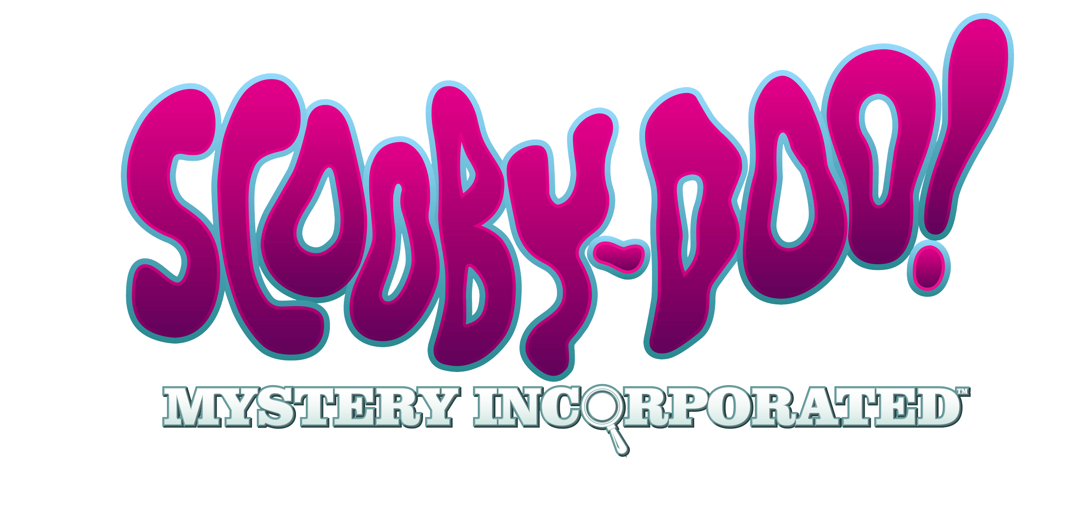
AYAKM Master Brief

Assignment /  Key Contacts | Scooby-Doo! Mystery Inc Master Brief  Marketing contacts: Lindsey Shuman / Rachel Parent
Background  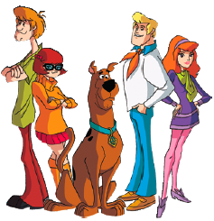 | Series Description:  Those famous four meddling kids and their talking dog are back, solving mysteries in the spooky town of Crystal Cove - a sleepy costal village, that boasts a long history of ghostly sightings, werewolves and glowing deep sea divers. And because this place is so haunted, Crystal Cove has become a tourist hotspot, taking in major profits. The Paranormal has been good to this town and the people of Crystal Cove don’t appreciate the gang’s meddling.  While all the townspeople are legitimately scared of the place, they never question anything and wholeheartedly believe in the supernatural.  But not Mystery Incorporated. The gang is curious and investigates every circumstance with a questioning mindset. If ghosts and monsters exist, so be it, but extraordinary claims require extraordinary proof and the gang will stop at nothing to learn the truth behind Crystal Cove.  Main Characters:  SCOOBY-DOO and Norville “Shaggy” Rogers – the soul of the team. Not so much interested in mysteries as they are in eating and watching horror movies. Currently involved in a complicated love triangle with…  Velma Dinkley – The brains of the team. Too smart and too aggressive for her own good sometimes. Velma loves mysteries, Shaggy, Science, and alternative music, in that order. She is not shy about letting her feelings known, and can’t understand why getting Shaggy to love her is so difficult. For this reason, she often turns to advice from her best friend…  Daphne Blake – The heart of the team. A Sweetie with no idea how hot she is. But don’t let her looks deceive you, Daphne is not a idiot. In fact, unlike previous incarnations of the show, she does a lot of mystery solving herself. And she loves doing it. Why? Because it brings her closer to Fred…. Daphne is eternally devoted to Fred and imagines them spending their entire lives together. Unfortunately for Daphne, there is one thing getting in her way. Fred is already in love… with his traps.  Fred Jones – The leader of the team. Fred has two goals in life: to be a great mystery solver, and to be an equally great trap builder. Beyond that, he’d like to spend the rest of his life living in a house with the gang…where they can solve m mysteries and build traps. As for his relationship with Daphne, Fred is at h the baby steps stage. Somewhere between realizing girls and boys are d different, and holding hands. But he’s getting there. Slowly.  - CN Launch Date: Mon July 12 @ 7p  - Co-Production: Cartoon Network and Warner Bros Animation  - 26 episodes
Positioning | Cartoon Network is home to the NEWEST Scooby animated series, Scooby-Doo! Mystery Inc - a contemporary re-envisioning of the classic Scooby franchise starring those four meddling kids and their talking dog fetching laughs and solving crime-frightening mysteries in the most haunted town in the world, Crystal Cove - all for a new generation of Kids 6 -11 to fill their weekly Scooby cravings!
Target Viewer | Kids 6-11 – Even Boy/Girl Split
Target Viewer Insights | - Scooby has high Awareness and Affinity with Boys, Girls and Moms!  - Boys 6-8: Q Score 64; Familiar – 95 (Spongebob - Q Score 74; Fam 97)  - Girls 6-8: Q Score 54; Familiar – 90 (Spongebob - Q Score 64; Fam 93)  - Moms of K2-11: Q Score 35; Familiar 98
Consumer Hooks | A Howling Good Time – The genuine silliness of Scooby & Shaggy and the added playfulness of the gang’s camaraderie, continues to bring laughs to a show that’s paws-itively a good time. Whether it’s dressing Scooby up as a baby or Daphne’s jealousy over Fred dating a dead girl, this show is doggone funny!  Crystal Cove Capers – Every episode is set in the haunted town of Crystal Cove and features a new spine-tingling mystery and nasty villain for the gang to investigate. A slimy mutant, an evil specter, a giant terrorizing crab…these mysteries will have your paws shaking. And if that isn’t frightening enough, there’s a season long “LOST” like story arc about the gang trying to uncover the true history behind why Crystal Cove is so haunted. The gang is aided along the way by the mysterious Mr. E, who will ultimately lead them to the discovery of a conspiracy of lies in Crystal Cove.
Mandatory Elements | - Please use all approved title treatments  - Use CN logo


